**WS15 - ASSOCIATIONS-AGGREGATION**

**DATE: 07th december 2021**

20 GUAMAN VEJARANO ANGEL DAVID

Inspector: Jhon Guitarra

Clases: 9/10

missing ( main class)

There aren't the class Simulador Display

Relationships: 7.5/10

1. Colony-Ant 1/1

2. Area-AntEater 1/1

3. Area-Cell 0.5/1 Wrong Way

4. Colony-Nest 1/1

5. Food Pile-Food 0.5/1 Wrong Way

6. Ant-Food 0.5/1 Wrong Way

7. Cell-Pheromone Drop 1/1

8. Area-Colony 1/1

9. Area-Food Pile 1/1

10. Simulator-Area 0/1 missing (main )

11. Ant-Pheromone 0/1 dependency

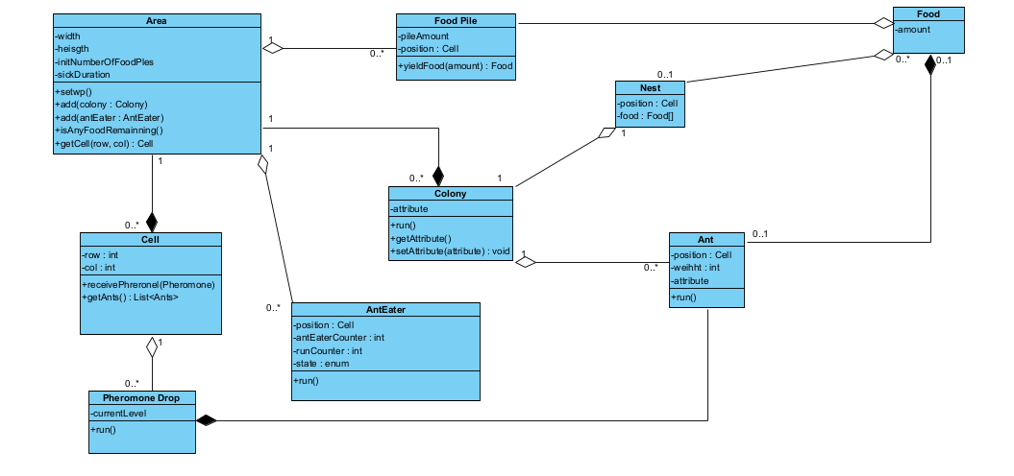

21 GUITARRA SANCHEZ JHON ALEXANDER  
Inspector: Jose Guzman

Clases: 7/10 +1 (Classes Direction and Position)

There aren't the classes main, area, and anteater

Colony-Ant 0.5/1 (The relation colony and ant it is backward)

Area-AntEater 0/1 (There aren't the relationship)

Area-Cell 0/1 (There aren't the relationship)

Colony-Nest 1/1

FoodPile-Food 1/1

Ant-Food 0/1 (There aren't the relationship)

Cell-PheromoneDrop 0/1 (There aren't the relationship)

Area-Colony 1/1

Area-Foodpile 0/1 (There aren't the relationship)

Main-Area 0/1 (There aren't the relationship)

Ant-Pheromone 1/1

Relationships: 4.5/10

